

**AFRIDEV SENSOR REVERSE ENGINEERING REPORT**

**Rev 4.1**



CONFIDENTIAL

Prepared by: Mathew Schreider, Rob Lieb and Doreen Swift

Date: September 25, 2016

**Product Background**

Charity Water has developed the Afridev Sensor product which can electronically track and analyze the water usage levels of wells deployed in remote locations. The Charity Water level sensing design consists of TI’s MSP430 microcontroller and 6 individual sensing pads; a SIM900 GSM module communicates water level data to the Charity Water’s servers where the data can be analyzed furthermore. The product hardware detects water levels through a capacitive sensing design implementation. The water use values are then derived from the MSP430 level sensing algorithms provided by TI.

Currently water use computations range from 80% to 120% of the actual pump water flow; this equates to a +/-20% error rate. Charity Water has asked IPS to assess the Afridev Sensor design and to make modifications to reduce the error rate to +/- 10%. IPS has been provided a sample unit for evaluation and test as well as the project documentation which includes the PCB schematic and layout.

There are many components which contribute to the capacitive characterization of the sensing pads. Capacitive sensing of the pads on the PCB must be able to sense water through the mechanical housing. Temperature within the well, temperature of the water and moisture within the housing are environmental variables which can affect the capacitance levels of the pads.

IPS set up test experiments in a more controlled environment than found in the field to ensure more consistent test results. Variations in test data should be a result of the system software and PCB hardware only; there should be no variations in data due to environmental conditions.

The Afridev Sensor system is designed to measure changes in capacitance as measured from a base value; it is not designed to measure absolute capacitance. This is achieved through the counting of oscillations on each sensor pad during a fixed time base. The greater the count, the lesser the capacitance. Each of the 6 pads has a distinct innate capacitance (in air) which can be characterized as a base count with this method.

Each pad is charged and discharged during a fixed window of time. The MSP430 microcontroller counts the number of charge and discharge cycles for each of the 6 pads. The number of counts is the raw data for a pad. Pad data “in air” establishes the capacitance baseline. Next the sensing pads were immersed in water, one by one, until all of the sensors were covered in water. Pads immersed in water will have a greater capacitive value than those in air. Based on the RC time constant equation, $τ=RC$, as capacitance, C, increases, the time constant, τ, also increases. The larger τ is, the longer it will take for each pad to charge and discharge. Sensor pad count values should be lower when the pad is immersed in water than when in air.

As part of the testing the system architecture, water sensing algorithm and system clocks were all reviewed. The source of the error rate needed to be identified and understood before IPS could implement modifications to make recommendations to reduce the error rate.

**Findings**

Within the PCB software lies the water level sensing algorithm. The software contains code from TI’s capacitive sensing libraries. If each pad is modelled as an ideal, parallel plate capacitor, the capacitance of each pad can be calculated:

$C=\frac{ϵA}{D}$ equation,

where $ϵ$ is the dielectric constant, A is the area of the plate and D is the distance between the plates. The dielectric constant of water is 80 as compared to that of air being 1. As each pad or plate is covered in water, the capacitance should increase by a factor of 80 based on the equation. In this design, the pad sensors are not ideal capacitors; there are other factors which contribute to overall capacitance including PCB trace length and spacing. Capacitance on each pad should increase as it is submersed in water but due to secondary effects, the increase will not be +80 pF. We did expect that as the pads were covered in water, the count values would decrease (capacitance and counter values have an inverse relationship).

While recording raw count data of the pads from the MSP430, we noticed outlier data in the collection process. When filtering out the outliers, the data trends became clearer. We were able to distinguish between a pad that was covered with water and a pad that was not. This data was collected at a fixed room temperature of 70 degrees Fahrenheit. We sampled each pad for one minute before moving onto the next pad. This allowed for the water level to settle to ensure the most accurate reading we could get. The count data collected is as follows in Table 1(outliers removed):

|  |  |  |  |  |  |  |  |
| --- | --- | --- | --- | --- | --- | --- | --- |
|  |  | Pad0 | Pad1 | Pad2 | Pad3 | Pad4 | Pad5 |
|  | Max | 39821 | 40649 | 39631 | 42611 | 43399 | 47918 |
|  | Mean | 39649 | 40591 | 39606 | 42583 | 43369 | 47881 |
| AIR | Min | 39616 | 40424 | 39582 | 42561 | 43345 | 47746 |
|  | GAP | 377 | 316 | 577 | 741 | 922 | 1006 |
| WATER | Max | 39240 | 40108 | 39005 | 41820 | 42424 | 46740 |
|  | Water | 39159 | 40027 | 38980 | 41802 | 42405 | 46721 |
|  | Min | 38605 | 39886 | 38903 | 41751 | 42388 | 46705 |

**Table 1 Pad counts**

Capacitance is also affected by changes in temperature and changes in humidity. When the Afridev Sensor is deployed in a pump, the base capacitance of the sensors will vary due to the environmental conditions. In Africa temperatures drop to as low as 45 degrees Fahrenheit in the month of June and July and can reach as high as 100 degrees Fahrenheit. The water level sensing is measured by detecting a change from the base count value. If the base is not constant, then the water level measurement will be inaccurate.

During the characterization process, we checked the impact of fingers placed on the pad housing and analyzed how the pad data reacted to touch. Touch sensing resulted in a greater and faster change in pad counts than that of water level sensing. It appears from information provided by Texas Instruments that the capacitive sensing methodology used in the Charity Water Afridev

Sensor design is more applicable to touch sensing rather than liquid level sensing. TI’s examples, models and libraries appear to be more applicable to touch sensing. The sensing technique employed in this design may not provide the accuracy that is desired by Charity Water. Further investigation would be required to be certain.

Charity Water’s Afridev Sensor sensing algorithm uses a “Calibration Process” which periodically re-establishes a maximum threshold value for each sensing pad. The calibration process cannot proceed until a five-minute period of continuous dryness is seen, and at least 20 minutes has lapsed since the last calibration cycle. When a new max threshold value is put in place, it is based on at least 10 minutes of historical data.

During normal operation, new thresholds are continuously set. Outliers in pad calibration measurements will be inaccurately assigned as the potential maximum value in the pad array. Outliers result in erroneous base measurements.

We examined the waveforms of the sensing pads on an oscilloscope to characterize the clock cycles and measuring periods. We confirmed that each pad capacitance measurement gate window s 16ms; each pad is gated in a serial manner for 16ms. For six pads, the total cycle time is 96ms (6x16ms). There is 80ms between a single pad’s falling edge and the next time it begins to count on its rising edge. The software reads the capacitive measurements once a second. IPS’ evaluation continuously read from the pad sensors to characterize their accuracy.

Figure 1 is an oscilloscope screen capture of Pad0’s pulse cycle. The period from the rising edge of Pad0 pulse to a subsequent Pad0 pulse rising edge is 96ms. This means that a full cycle for all 6 pads to be measured is 96ms. Time between Pad0 pulses is 96m, time between Pad1 pulses is 96ms, etc.; this is the period of each pad measurement cycle. Each pad should have a high level gate window (high width) of 16ms. It is during the high pulse width that the capacitance is measured through counting.

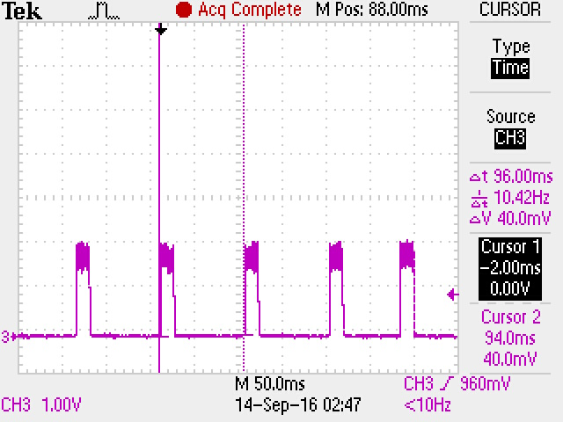

Period of “normal” pulse

**Figure 1 Typical measurement cycle timing**

There are occasions where the period between same pad pulses is not 96ms. This can be seen in Figure 2 where Pad0 shifts 16ms in time to the left. The period between pulses is 80ms instead of the “typical” 96ms. The timing is inconsistent and may indicate that another one of the other pads was not part of the cycle count. It is likely that this anomalous behavior is caused by software timing issues. A reset may be occurring inside the timer. Based on observations, these pulse shifts appear to occur every 2 seconds.

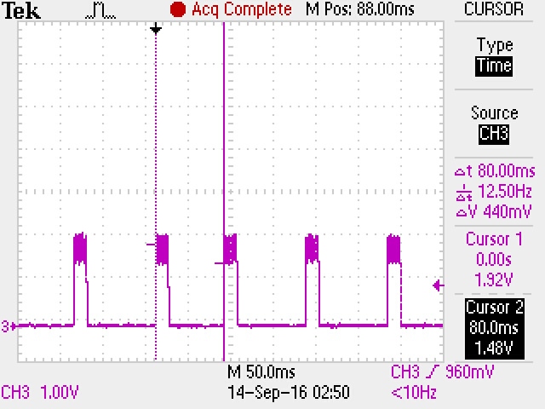

Period of “shifted” pulse

**Figure 2 Inconsistent pad period**

Another inconsistency appears to be the sensing pad gate width or the high pulse time. The measurement of the capacitive value is achieved by counting the pulses within a constant gate window. Under normal conditions, each pad is gated for 16ms in succession (Pad0🡪Pad1🡪Pad2…...Pad6🡪Pad0…). Occasionally, the pad gate window will differ in width (2.5ms) which will have a significant impact on the pad count value. This is likely to be caused by software (some critical timing error). The scope capture shown in Figure 3 illustrates Pad0 with a very small pulse width. Inconsistent gating windows will cause inconsistent pad count values.

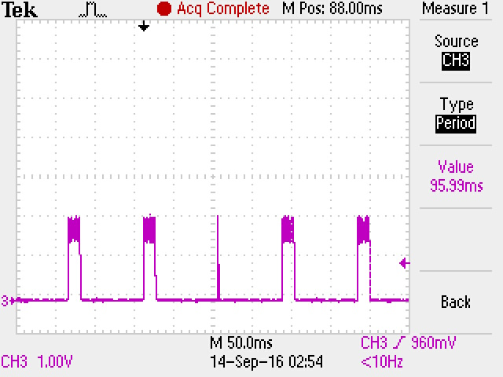

**Figure 3 Abnormal gate time pulse width**

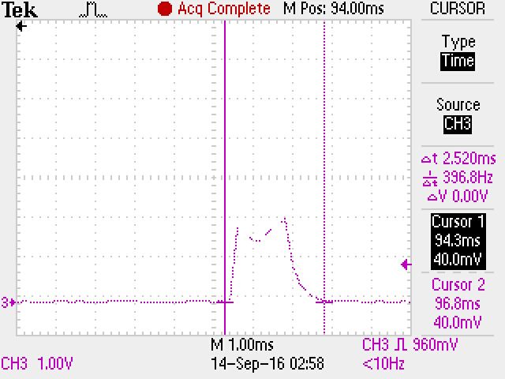

Width of “skinny” pulse

**Figure 4 Zoomed in view**

Figure 4 shows a zoomed in picture of the narrow pulse width. This narrow window will lead to inaccurate pad counts. Invalid pad counts will cause inaccurate water flow values.

**Summary**

The total pad measurement period (cycle time for 6 sensor pads to be measured) and pad gate windows both appear to be inconsistent in duration. Both should contribute to the inconsistent test results. IPS observed this during testing and labelled these results as “outlier data”. Unpredictable gate times will cause inaccuracies in both base count and capacitive change count. Further investigation of the software will be needed to determine the root cause.

Once the source(s) of timing variability are addressed, then some attention can be given to the error rates caused by other factors. Based on IPS’ investigation and testing, we have concluded that there are a number of hardware and software factors which contribute to data inaccuracy including the “Calibration” algorithm, environmental conditions, and sensing methodology. Although error rate was not characterized, testing results indicate that a +/- 20% error rate is plausible.

**Next Steps**

Although the Charity Water Afridev design will detect changes in water level, the hardware implementation may not give the desired accuracy. It may be possible to reduce the error rate of the Afridev Sensor to within +/-10%, but further testing and characterization of the design across all temperatures and varying humidity will be required before we can be certain.

IPS would recommend that Charity Water brainstorm and investigate other approaches to sensing the water use at the remote pumps. This would include different electronic liquid level sensing techniques (capacitive or resistive), flow meters, turbines, etc. There may be other sensing mechanisms available which are better suited for the application and less sensitive to environmental conditions, ultimately providing the accuracies Charity Water desires.